

|  |  |
| --- | --- |
| **Benha University** | **Shoubra Faculty of Engineering** |
| **1styear (2016-2017)** | **Electrical Engineering. Dept.** |
| **Thermodynamics Sheet No. (2)** | **Communication engineering** |

1. A gas contained within a piston-cylinder assembly expands in a constant-pressure process at 4 bar from v1=0.15 m3 to a final volume of v2=0.36m3. Calculate the work, in KJ.
2. A gas expands from an initial state where the pressure is 340kpa and the volume is 0.0425m3 to afinal state where the pressure is 136kpa. The relationship between the pressure and volume of the gas during the process is PV2=constant. Sketch the process on a P-V diagram and determinethe work ,in kJ
3. Consider as a system the fluid contained in the cylinder as shown in fig. the fluid expands from 0.04 to 0.043 m3, while the pressure remains constant at 690kpa and while the paddle wheel does 4880 Joule of work on the system. How much work is done by the system on the piston? What is the net amount of work done on or by the system?

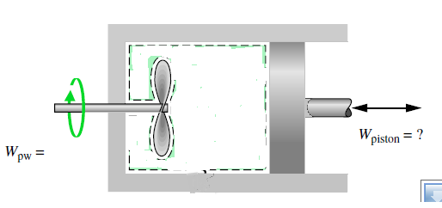

1. Water initially at 50kpa, 100oC is contained in a piston and cylinder assembly with an initial volume of 3m3. The water is then solely compressed according to the relation PV=constant until a final pressure of 1Mpa is reached. Determine the work for this process
2. A gas is compressed from V1=0.09 m3 to V2=0.03 m3. The relation between pressure and volume during the process is P=14V+2.44, where the unit of P, V are bars and m3respectively. for the gas , find the work in KJ
3. Air undergoes two processes in series. Process1-2, expansion from P1=300kpa, V1=0.19m3/kg to P2=150kpa during which the pressure – volume relationship is PV=constant.Procee2-3 constant -pressure compression to V3=V1 .Sketch the process on a P-Vdiagram and determined the work per unit mass of air, in KJ/kg.